1. Format all cells -> Autofit column width
2. No duplicate values found
3. Set DATE (DateTime) to long date format
4. Set BASE_COST as USD currency
5. Remove ‘(procedure)’ for increased readability

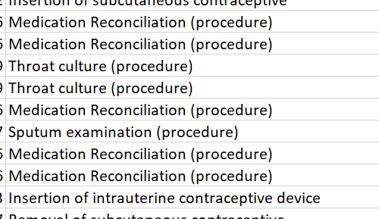

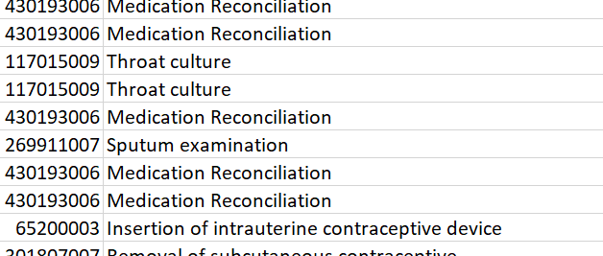

1. Fill blank values with NA